#### Name___Robert Thomas_________________ Score __________ / 25

#### GNumber __G#01055775___________

## CS 100 - Principles of Computing

**Assignment 1**  
**Bits, Bytes, Hex and ASCII**

For this assignment you will be encoding and decoding the most fundamental aspect of computer languages, bits. You will need to reference the following ASCII table:

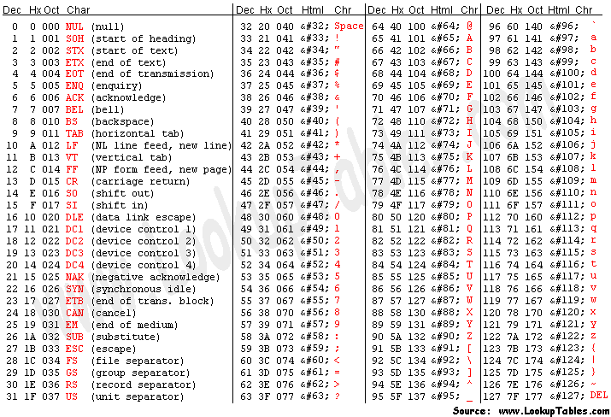

and might also need to use the table of Powers of 2 given below:

|  |  |  |  |  |  |  |  |  |  |  |
| --- | --- | --- | --- | --- | --- | --- | --- | --- | --- | --- |
| 20 | 1 |  | 24 | 16 |  | 28 | 256 |  | 212 | 4096 |
| 21 | 2 |  | 25 | 32 |  | 29 | 512 |  | 213 | 8192 |
| 22 | 4 |  | 26 | 64 |  | 210 | 1024 |  | 214 | 16384 |
| 23 | 8 |  | 27 | 128 |  | 211 | 2048 |  | 215 | 32768 |

**You may NOT use any other resources (internet, calculator, etc) other than your notes, class slides, and pen/pencil and paper!**

1) Fill in the chart with the proper ASCII values and characters (3 Points):

|  |  |
| --- | --- |
| ASCII Character | ASCII Value in Decimal |
| A | 65 |
| 0 (zero) | 48 |
| ! | 33 |
| + | 43 |
| Z | 90 |
| z | 122 |

2) Give the binary representation for each ASCII value in #1 above. Transfer your answer from the first three rows in #1 above to the first column (3 Points):

|  |  |
| --- | --- |
| ASCII Value in Decimal | ASCII Value in Binary |
| 65 | 0100 0001 |
| 48 | 0011 0000 |
| 33 | 0010 0001 |
| 43 | 0010 1011 |
| 90 | 0101 1010 |
| 122 | 0111 1010 |

3) Fill in the chart with the proper hexadecimal or binary values (3 Points):

|  |  |
| --- | --- |
| Value in Binary | Value in Hexadecimal |
| 1101 1001 1011 | D9B |
| 0111 0110 0011 | 763 |
| 1010 0111 0100 | A74 |
| 1010 1000 0100 | A84 |
| 1100 1001 0111 | C97 |
| 1011 0000 0110 | B06 |

4) Decode the binary message and show what it is in ASCII characters. (Note: There are Typos, so don't make assumptions...) You *might* find it easier to convert to Hexadecimal first. (10 Points)

01010100 01101000 01100101 00100000 01100010 01100101 01100110 01110100 00100000 01100011 01101100 01100001 01110011 01010011 00100000 01110100 01101111 00100000 01110100 01100001 01001011 01100101 00100000 01100001 01110100 00100000 01000111 01001101 01010101 00100000 01101001 01011010 00100000 01000011 01010011 00110001 00110001 00110000 00100001 00111111

Message in ASCII:

The beft clasS to taKe at GMU iZ CS110!?

5) Convert the following message to Hexadecimal values. (Leave spaces between each value.) (6 Points):

Will this task ever END?

Message in Hexadecimal:

57 69 6C 6C 20 74 68 69 73 20 74 61 73 6B 20 65 76 65 72 20 45 4E 44 3F

Extra Credit (Up to three additional points):

A) The unicode character:

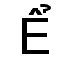

is called “**LATIN CAPITAL LETTER E WITH CIRCUMFLEX AND HOOK ABOVE**.”

Its encoded value is 7874 decimal. Give its UTF-8 encodings in:

Hexadecimal (1 point) -

1EC2

Binary (1 point) -

00011110 11000010

B) Given the following UTF-8 Hexadecimal encoding, give the unicode character’s value in decimal. You don’t need to name or write the actual character.

0xCFBE (1 point) -

1022